**ONLINE EXAMINATION SYSTEM**

**Submitted by**

Taher Ali

Abhay Singh Hada

**Guide Name**

Mr. Sanjay Rathor

Mr. Ankush Sharma

**Company Name**

Grass Solution Pvt. Ltd.

**College Name**

Career Point University, Alaniya , Kota

**TABLE OF CONTENTS**

1. **Introduction**
2. **Objective**
3. **Scope**
4. **Feasibility**
5. **Requirement specification (Technical)**
6. **Website Design**

**INTRODUCTION**

Today Online Examination System has become a fast growing examination method because of its speed and accuracy. Online Examination System is the simplest to use web-based application for schools, colleges, university, coaching classes, training centers, certification agencies, recruitment firms to conduct timer-based, completely automated paperless examinations.

It is also needed less manpower to execute the examination. Almost all organizations now-a-days, are conducting their objective exams by online examination system, it saves students time in examinations. Organizations can also easily check the performance of the student that they give in an examination. As a result of this, organizations are releasing results in less time. It also helps the environment by saving paper.

**OBJECTIVES**

1. To provide registration for student done by themselves.
2. When student starts the exam the timer will start automatically and show the student how much time is left.
3. Objective answers will be checked automatically by the system from the database.
4. It gives accurate result in very less time.
5. User-friendly systems.
6. Reports and performance analysis.
7. Offering several types of questions.
8. Easily used by user.
9. Reliable and accurate.
10. There is no need of examiner
11. No paper being used.
12. It will be Cost effective.

**SCOPE**

* This can be used anywhere any time as it is a web based application (User location doesn’t matter).
* No need that examiner has to be present when the candidate takes the test.
* Design to facilitate administrator and user.
* Complete and safe information is provided to user.
* This can be used in educational institutions as well as in corporate world.

**Feasibility**

The feasibility study of any system is mainly intendent to study and analyse the proposed system and to decide whether the system under consideration will be viable or not after implementation. This is it determines the usability the project after deployment.

1. **Technical Feasibility:** In technical feasibility, we study all technical issues regarding the proposed system. It is an evaluation of the hardware and software and how it meets the need of the proposed system.

* This project on online examination system will be platform independent since it is being coded in Angular Scripting language.
* HTML And CSS is used to create web pages.
* MONGO DB database will be used for storing data.
* Hardware requirements used are compatible with all OS.
* Only authorized person would be able to use this website so it would be secure.

1. **Operational Feasibility:** Operationalfeasibility is a measure of how well a proposed system solves the problems.

* This system will be simple to use for users.
* This system is user friendly and user can easily interact with the system.

1. **Economical Feasibility:** The purpose of the economic feasibility assessment is to determine the positive economic benefits to the organization that the proposed system will provide.

* This system will be Cost effective.
* It helps the environment by saving paper.
* It will consume less time.

**Requirement specification (Technical)**

**Software Requirements:**

Operating System: Windows 2010

Front End : HTML5, CSS3 , JS , Angular , Typescript , Bootstrap 3

Back End : JavaScript , Express.JS , Node.JS

Database :MONGO DB

Tool used :VS Code

**User Requirement:**

An active internet connection

Any web browser (Chrome, Firefox, Opera etc)

**Website Design**

**Home Page**

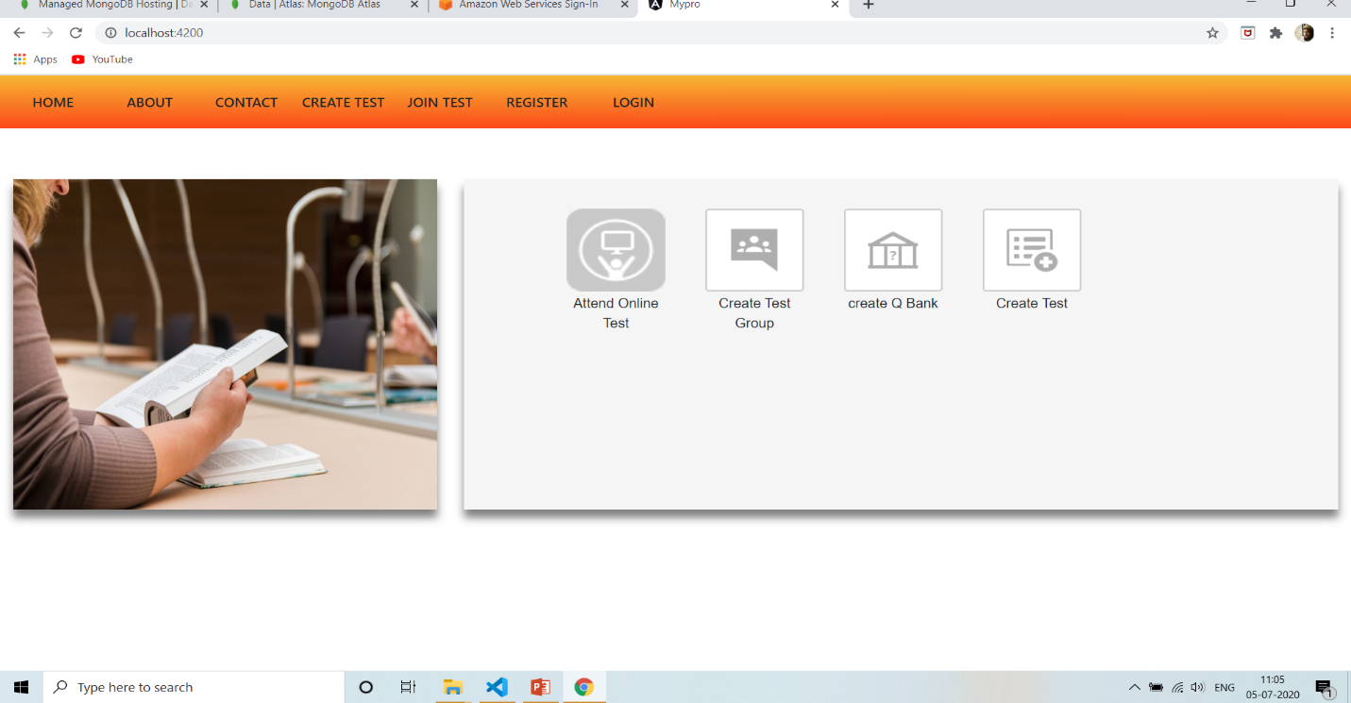

**Teacher Account Homepage**

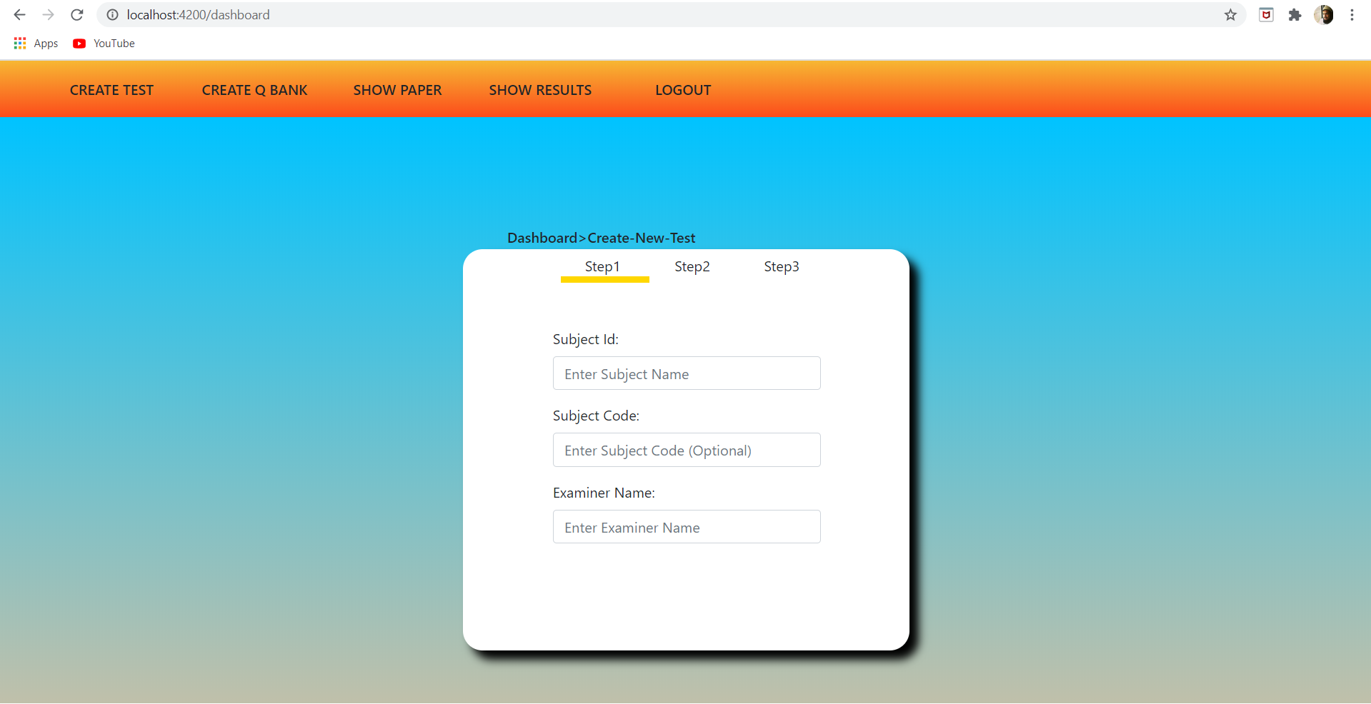

**Student Account Homepage**

